***Unit – IV: Analytic Functions***

***PART A***

***MULTIPLE CHOICE QUESTIONS***

1. Cauchy – Riemann equation in polar co-ordinates are

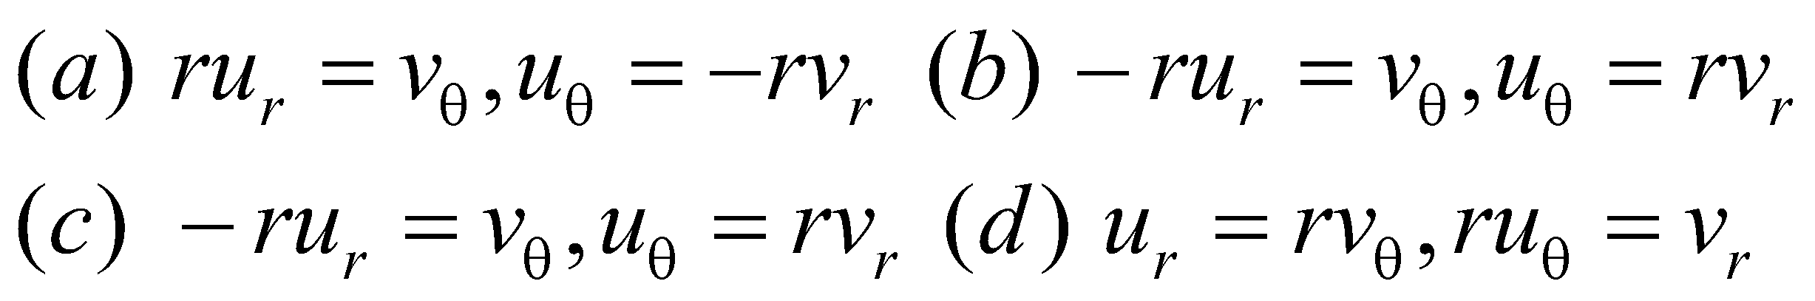

1. If w = f(z) is analytic function of z, then

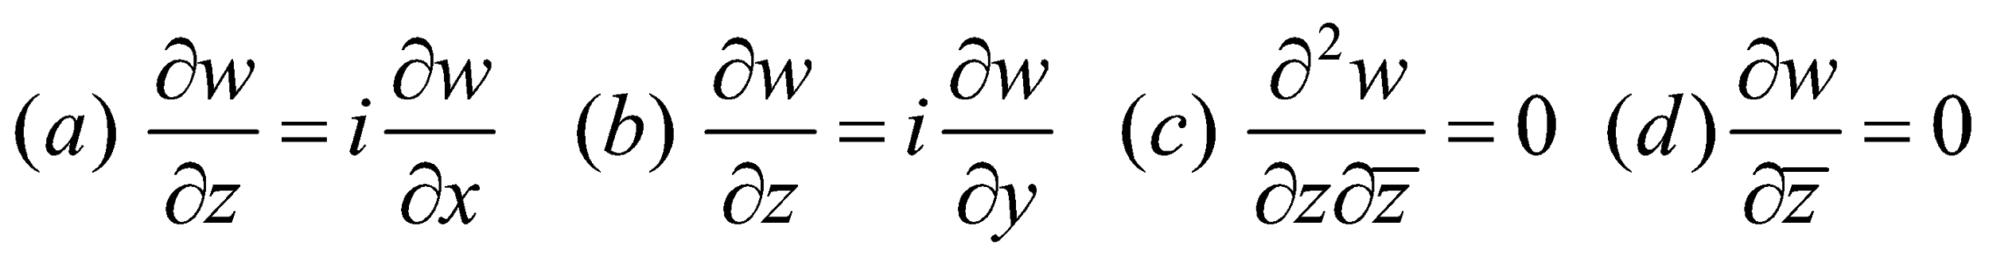

1. The function f(z) = u + iv is analytic if

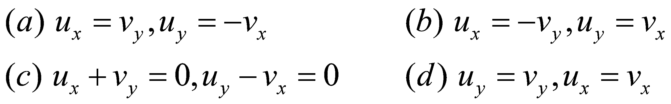

1. The function 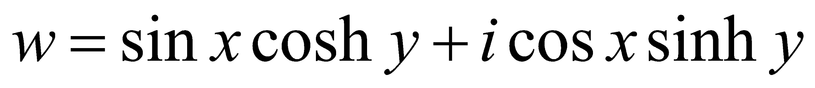 is

(a) need not be analytic (b) analytic (c) continuous (d) differentiable at origin

1. *u(x,y)* can be the real part of an analytic function if

(a) u is analytic (b) u is harmonic (c) u is discontinuous (d) u is differentiable

1. If *u* and *v* are harmonic, then *u + iv* is

(a) harmonic (b) need not be analytic (c) analytic (d) continuous

1. If a function u(x,y) satisfies 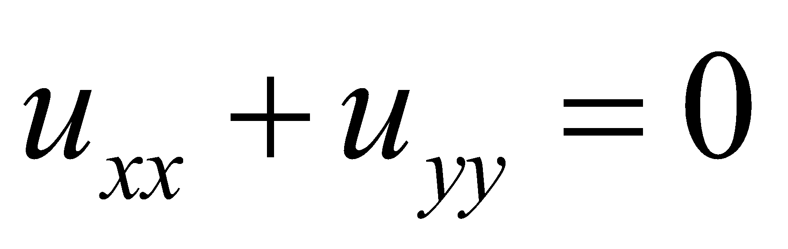, then u is

(a) analytic (b) harmonic (c) differentiable (d) continuous

1. The function 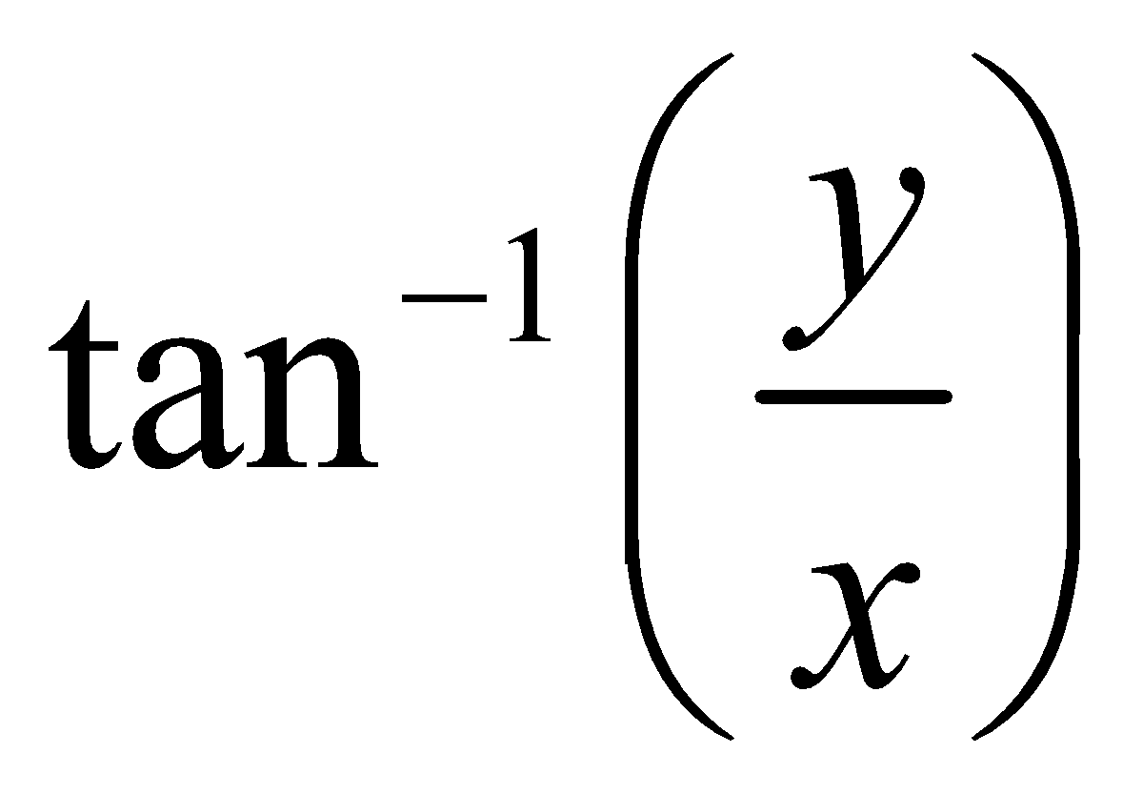 is

(a) analytic (b) need not be analytic (c) harmonic (d) differentiable

1. If u + iv is analytic, then the curves 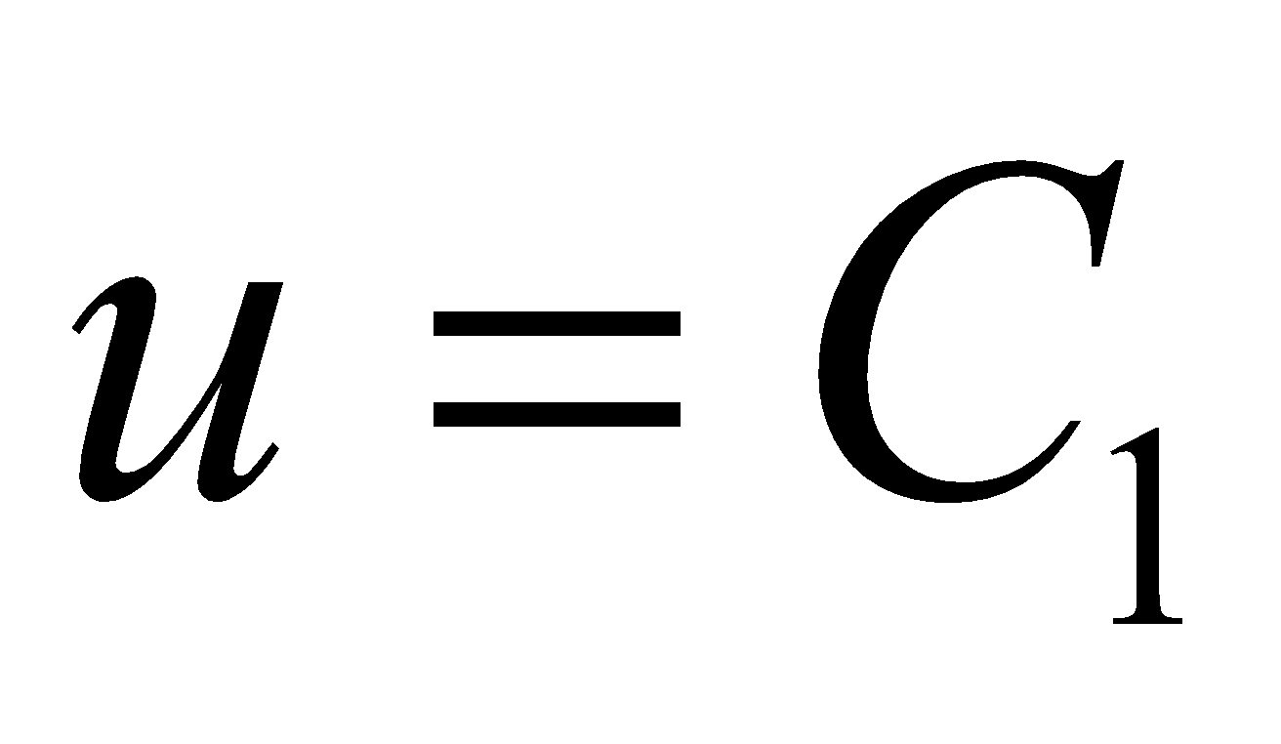 and 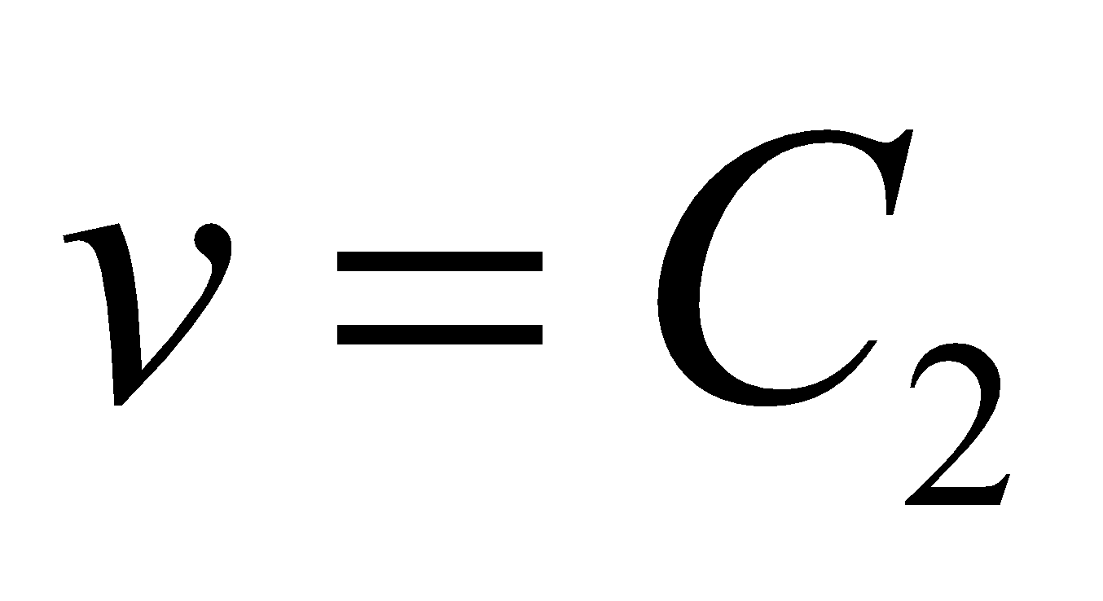

(a) cut orthogonally (b) intersect each other (c) are parallel

(d) coincides

1. The invariant point of the transformation 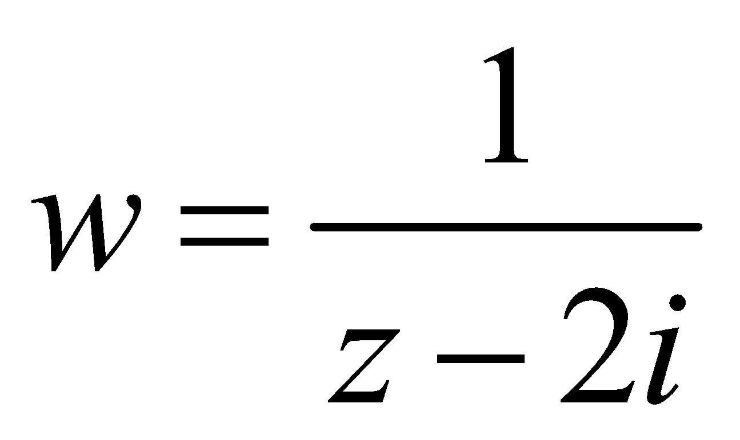 is



1. The transformation *w = cz* where c is real constant known as

(a) rotation (b) reflection (c) magnification (d) magnification and rotation

1. The complex function w = az where a is complex constant geometrically implies

(a) rotation (b) magnification and rotation (c) translation (d) reflection

1. The values of 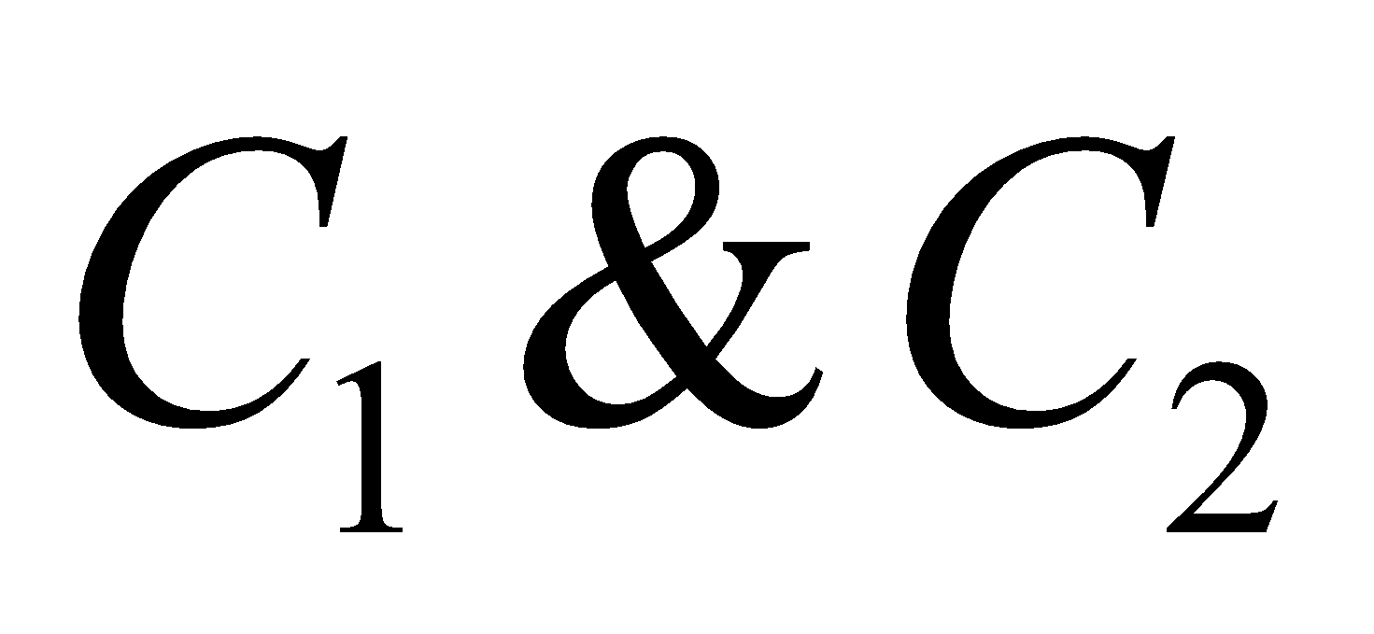 such that the function 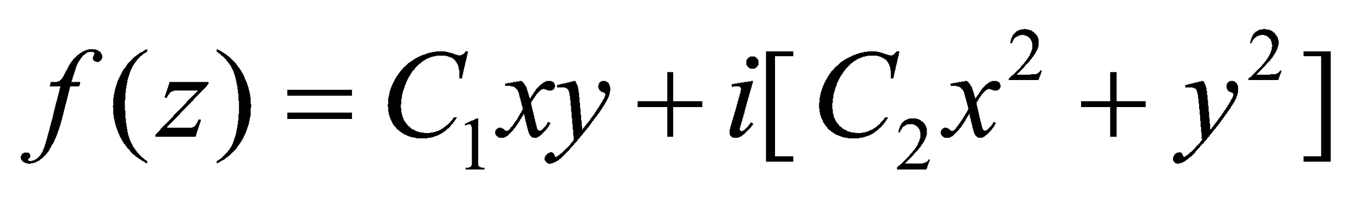 is analytic are

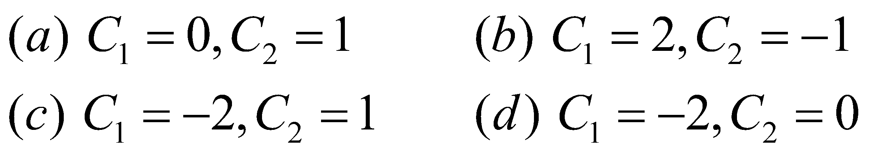

1. The real part of 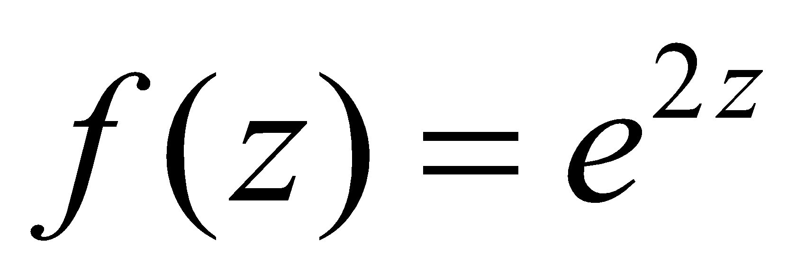 is



1. If *f(z)* is analytic where 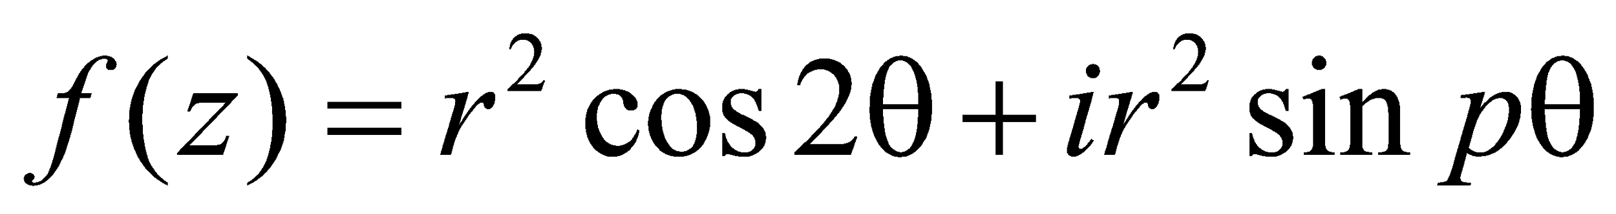, the value of p is



1. The points at which the function 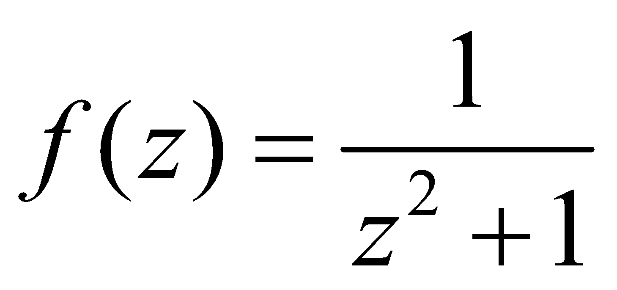 fails to be analytic an



1. The critical point of transformation 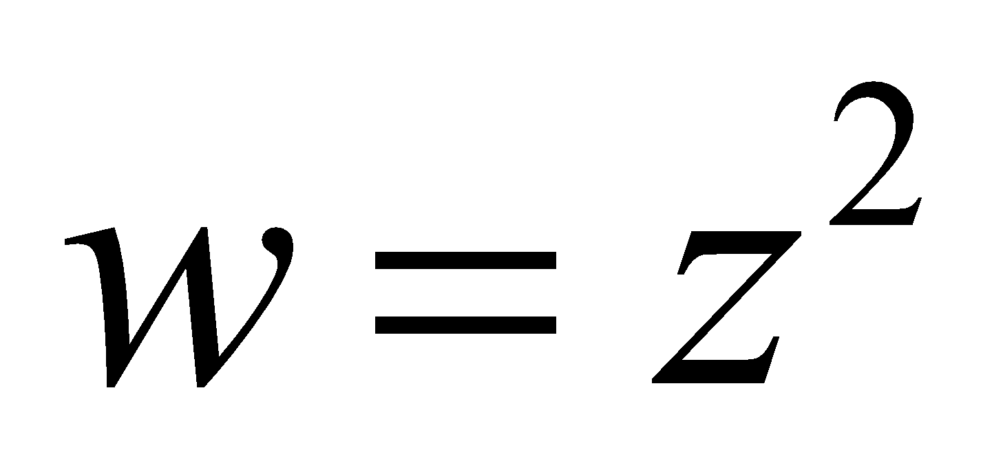 is



1. An analytic function with constant modulus is

(a) zero (b) analytic (c) constant (d) harmonic

1. The image of the rectangular region in the z-plane bounded by the lines x = 0, y = 0, x = 2 and *y = 1* under the transformation w = 2z.

(a) parabola (b) circle (c) straight line (d) rectangle is magnified twice

1. If f(z) & 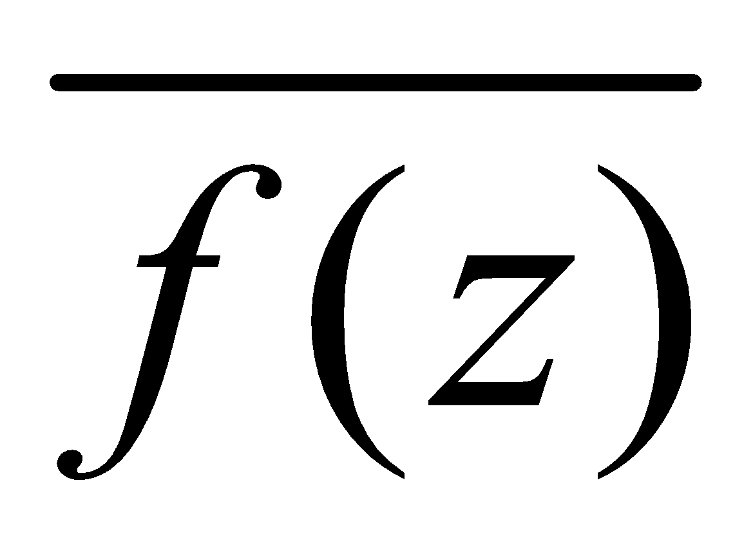 are analytic function of z, then f(z) is

(a) analytic (b) zero (c) constant (d) discontinuous

1. The invariant points of the transformation 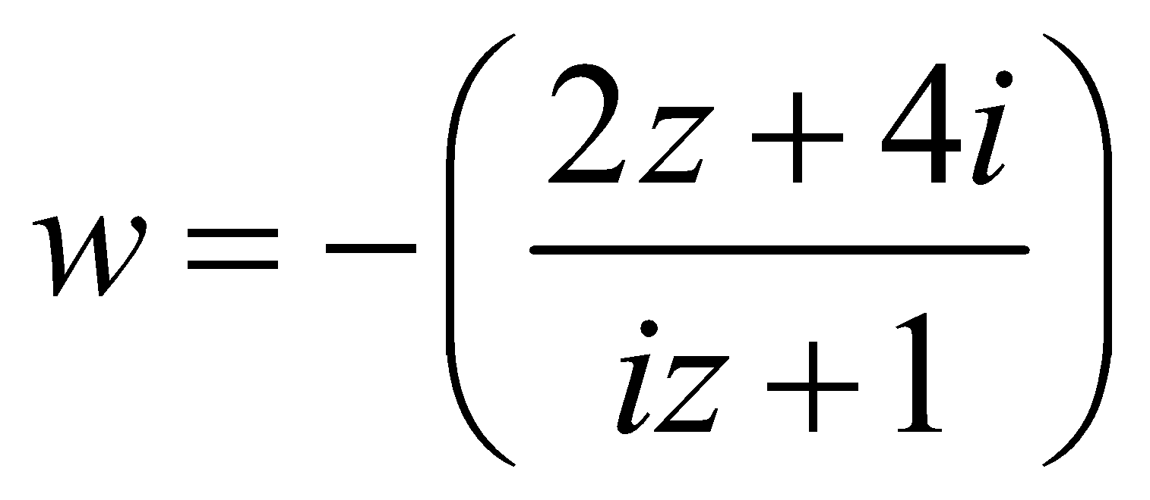 are



1. The function 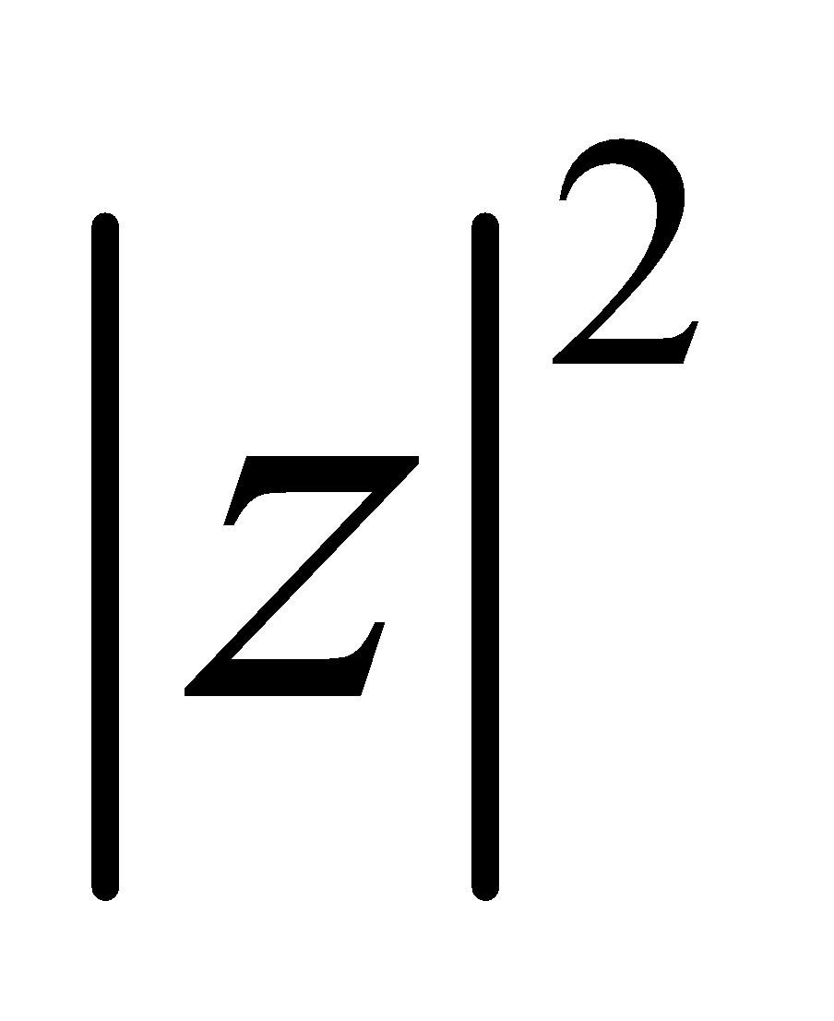 is

(a) differentiable at the origin (b) analytic (c) constant (d) differentiable everywhere

1. If f(z) is regular function of z then,

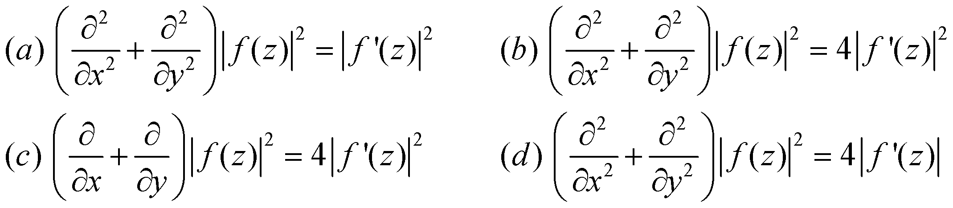

1. The transformation w = z + c where c is a constant represents

(a) rotation (b) magnification (c) translation (d) magnification & rotation

1. The mapping 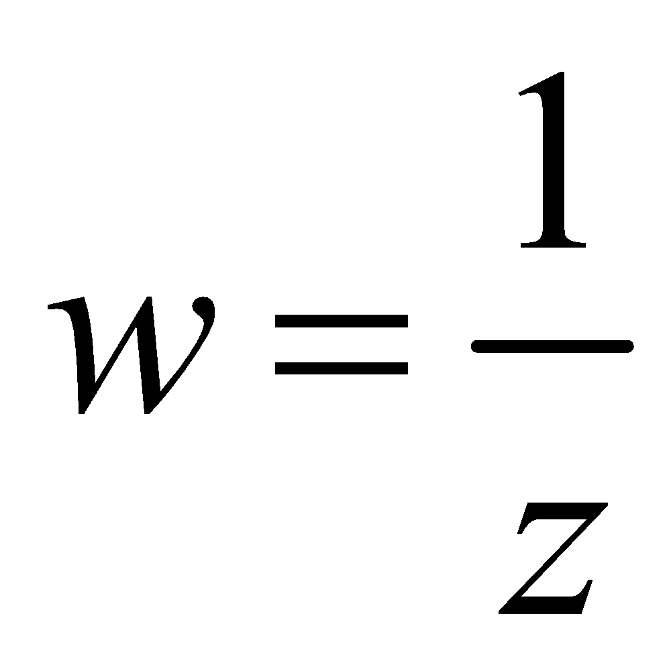 is

(a) conformal (b) not conformal at z = 0 (c) conformal every where

(d) orthogonal

1. The function 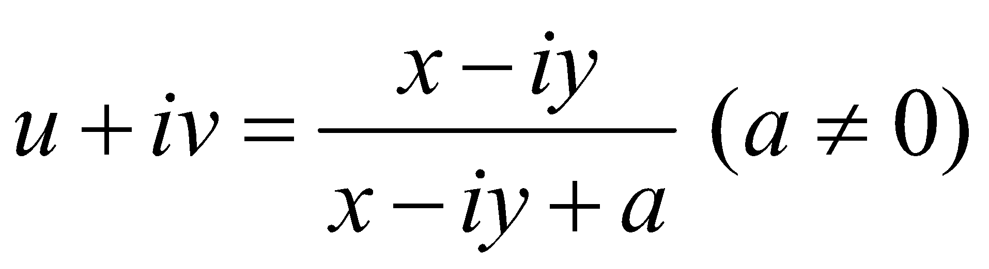 is not analytic function of z where as u – iv

(a) need not be analytic (b) analytic at all points (c) analytic except at z = - a

(d) continuous everywhere

1. If 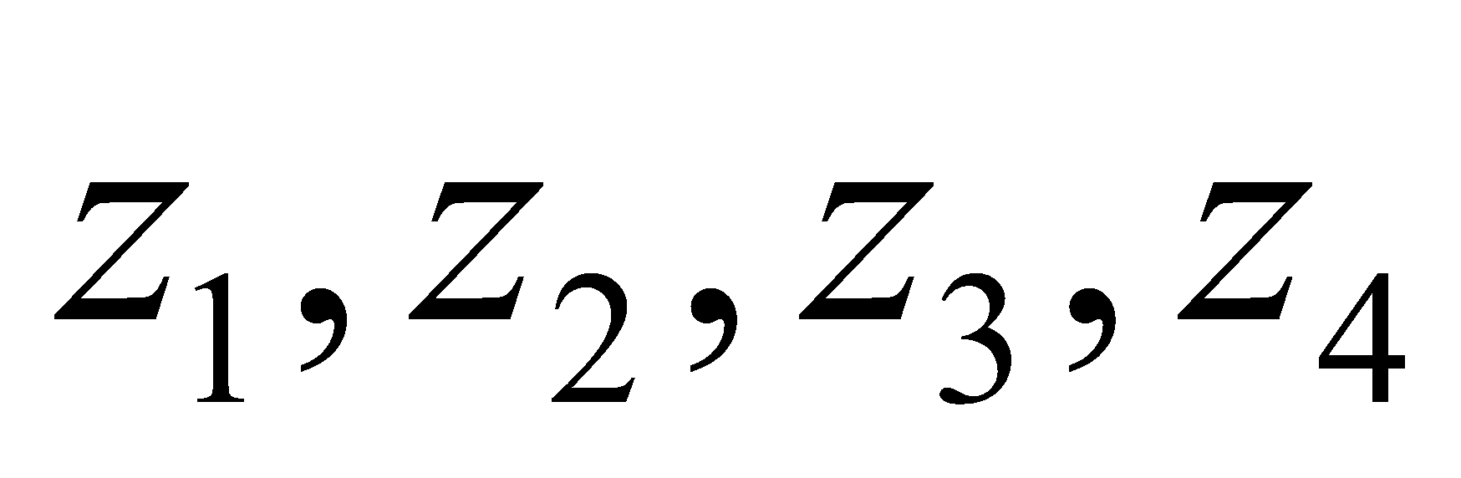 are four points in the z-plane then the cross-ratio of these point is

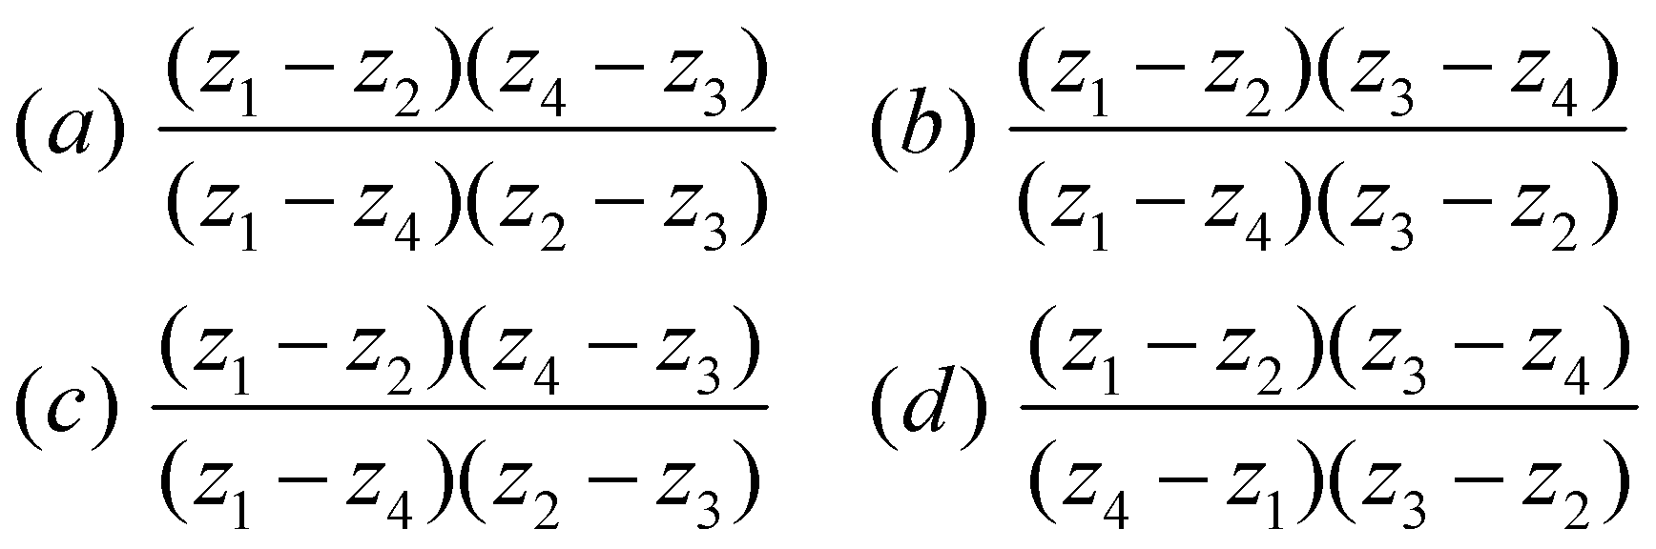

1. The values of the determinant of the transformation 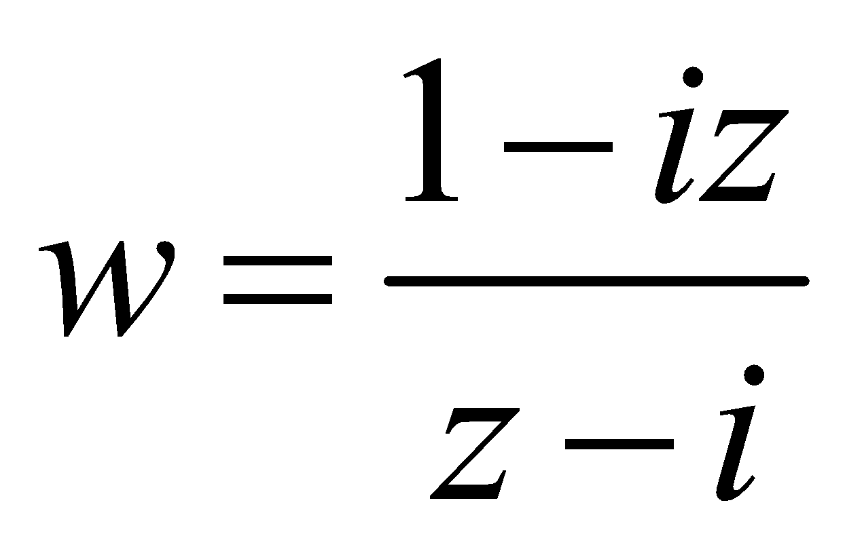

(a) zero (b) 2 (c) - 2 (d) 1